***UNEARTHING THE ENVIRONMENTAL IMPACT OF HUMAN ACTIVITY: A GLOBAL CO2 EMISSION ANALYSIS***

# 1 INTRODUCTION

# 1.1 OVERVIEW

Carbon emissions affect the planet significantly, as they are the greenhouse gas with the highest levels of emissions in the atmosphere. This, of course, causes global warming and ultimately, climate change. Carbon dioxide is released into the atmosphere when fossil fuels — coal, natural gas, and oil — are burned. But burning other biological materials also releases carbon dioxide: solid waste, trees, etc. Anytime that carbon dioxide is emitted into the atmosphere in large quantities — especially if it’s staying in the atmosphere for thousands of years — it is affecting the planet.

# 1.2 PURPOSE

CO2 emissions analysis in Tableau helps to understand the trends, patterns, and impacts of carbon dioxide emissions on the environment. It enables us to create visualizations that tell a story of how human actions and decision-making affect atmospheric CO2 levels.

## Tableau CO2 emissions analysis helps to:

* + - Visualize the trends and patterns of CO2 emissions over time, by region, industry, or sources.
    - Explore the relationship between carbon dioxide emissions and other environmental factors such as temperature, precipitation, and air quality.
    - Identify the biggest contributors of CO2 emissions in different industries and regions.
    - Evaluate the effectiveness of mitigation and reduction measures already in place.
    - Track progress towards environmental goals and targets like the Paris Agreement.

By providing these valuable insights, CO2 emissions analysis in Tableau can help inform decision-making, guide policy, and enable organizations to improve their environmental performance.

# 2 PROBLEM DEFINING AND DESIGN THINKING

2.1 Empathy MAP

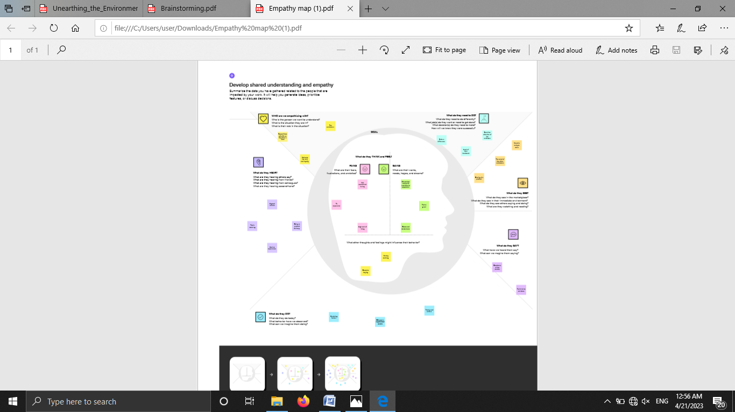

2.2 IDEATION AND BRAINSTORMING

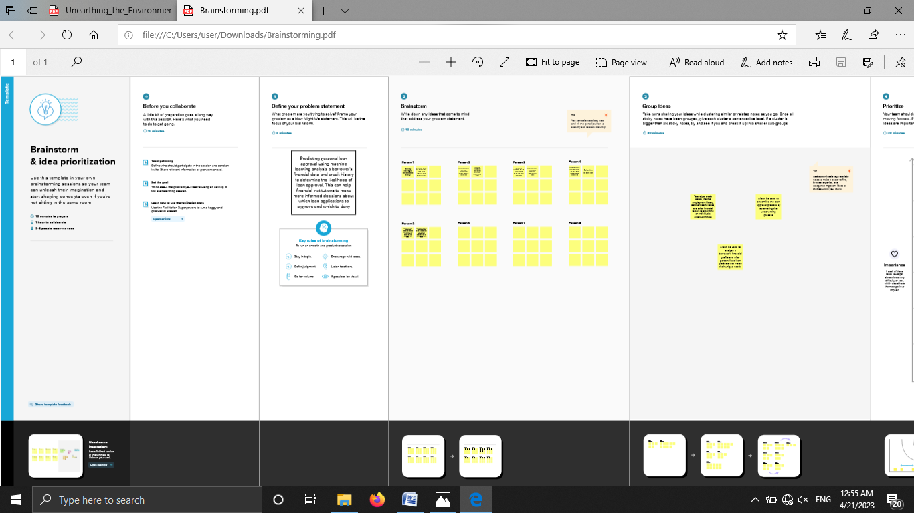

# 3 RESULT

We have made data visualization using tableau . The visual graphs helped us to understand the data collected throughout the world easily.

In 2020, the largest emitters were in China, the U.S., India, Russia, and Japan.

1. China

China is the largest emitter of carbon dioxide gas in the world, with 10,668 million metric tons emitted in 2020. The primary source of CO2 emissions in China is fossil fuels, most notably those that burn coal. About 55% of the total energy generated by China in 2021 came from coal alone, and because coal is rich in carbon, burning it in China's power and industrial plants and boilers releases large amounts of CO2 into the atmosphere.

2 .United States

The U.S. is the second-largest emitter of CO2, with 4,713 million metric tons of total carbon dioxide emissions in 2020. The largest sources of CO2 emissions in the U.S. came from transportation, power generation, and industry in 2020. Even though the U.S. government undertook significant efforts to reduce the reliance on coal for electricity generation, the country has become a major producer of crude oil.

3. India

India is the third-largest CO2 emitter, with 2,442 million metric tons of total carbon dioxide emissions produced in 2020. Coal is the main energy source for India, supplying about 45% of the energy in the country. Petroleum and other liquids provided about 26%.

4. Russia

Russia is the fourth-largest contributor to CO2 emissions in the world, emitting 1,577 million metric tons in 2020. Russia has one of the largest natural gas deposits in the world, and natural gas is the primary source of energy and power generation in the country.

5. Japan

Japan is the fifth-largest producer of CO2 emissions, with 1,577 million metric tons in 2020. Japan's energy fuel mix changed after the 2011 nuclear accident at Fukushima. Oil is the largest source of energy in Japan, with its total share of energy consumption being 40% in 2019 .

# SHEETS

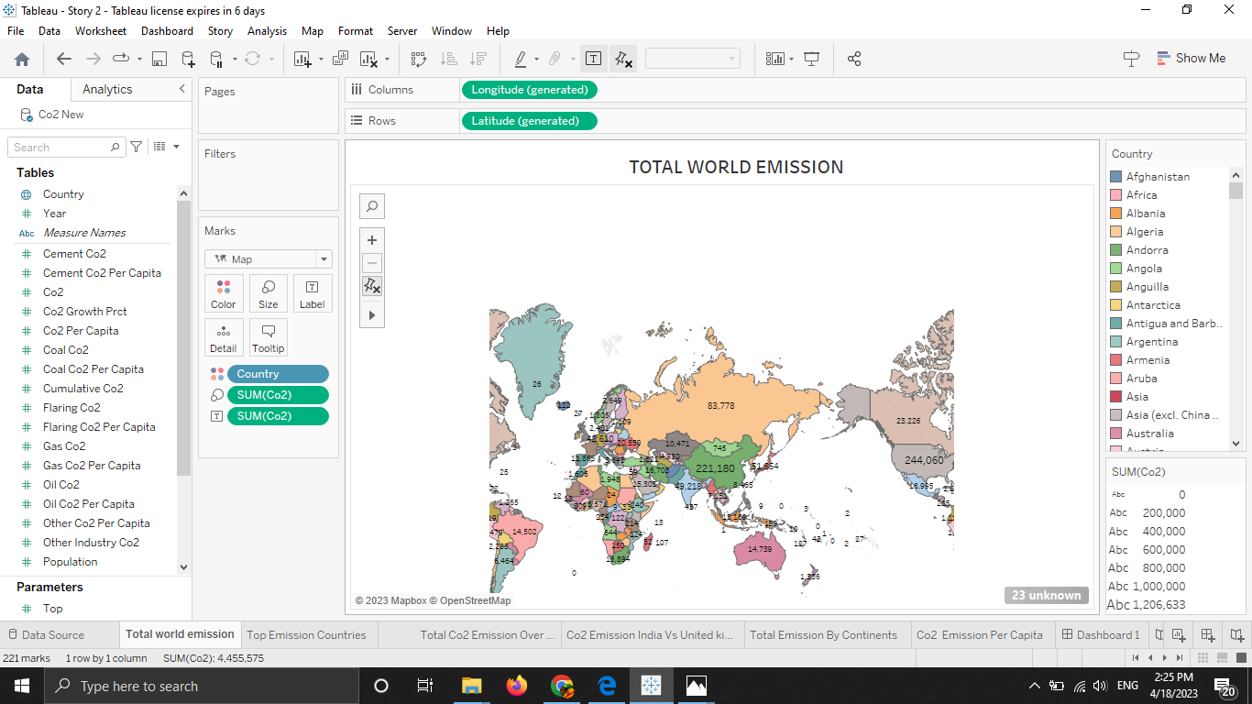

Fig:1 Top World Emission 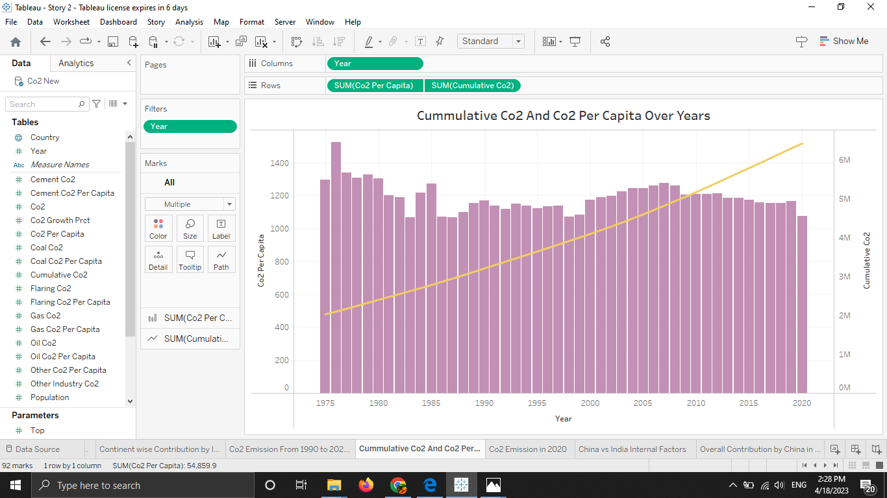 Fig:2 Cummulative Co2 and Co2 Per Capita Over Years

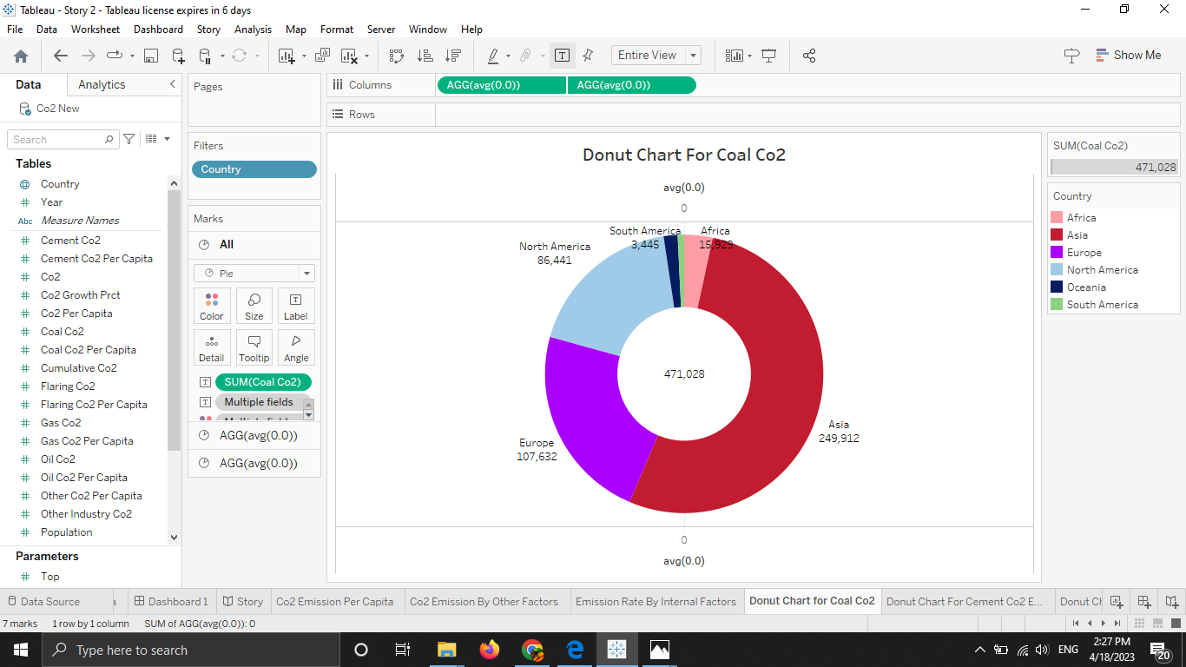

Fig:3 Donut Chart for coal Co2

# Dashboard

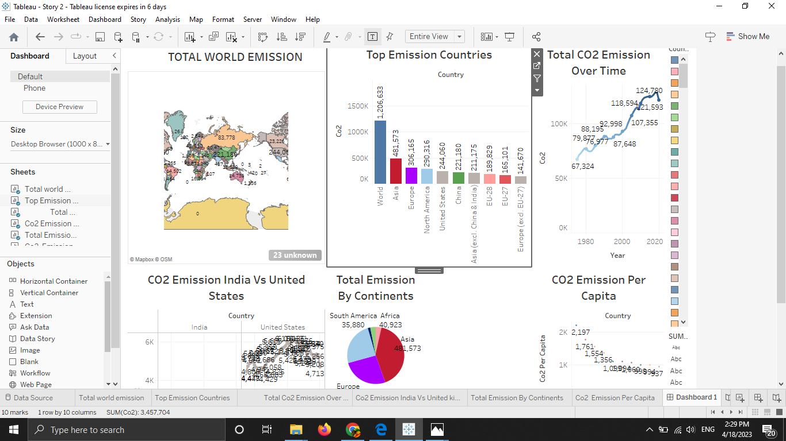

Fig4: Dashboard 1

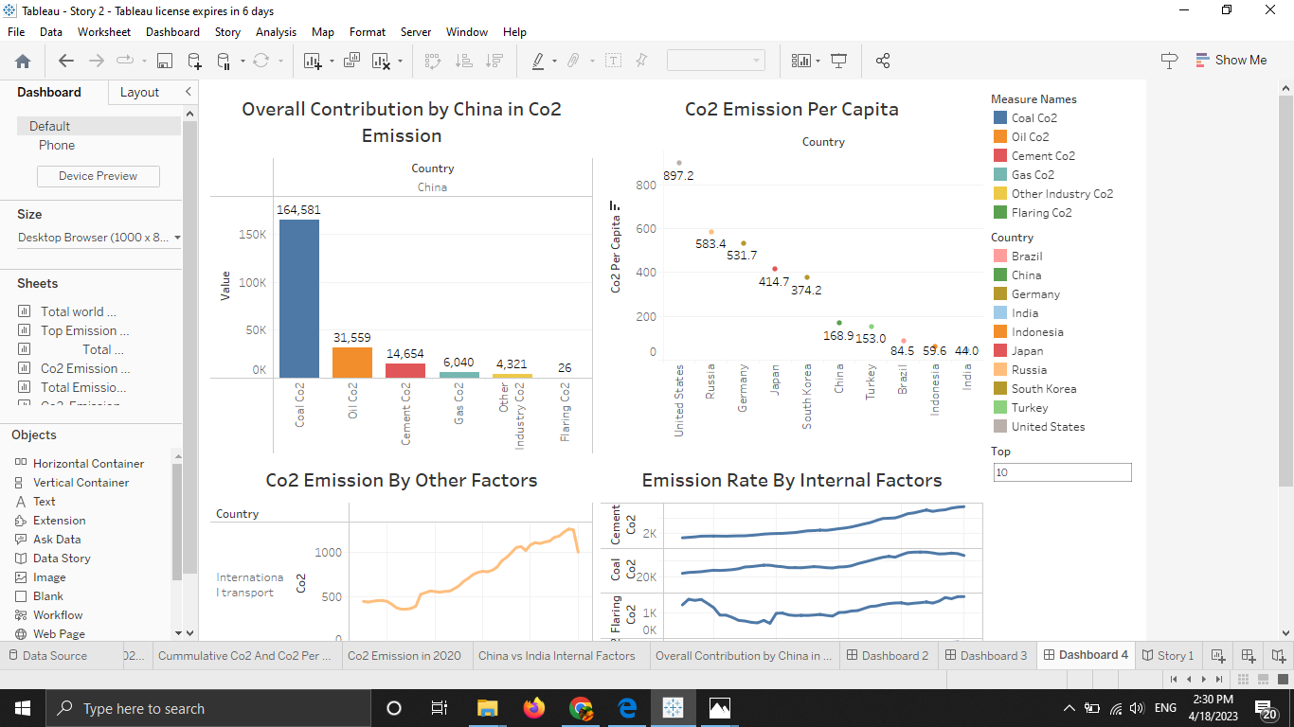

Fig 5: Dashboard 2

# Story

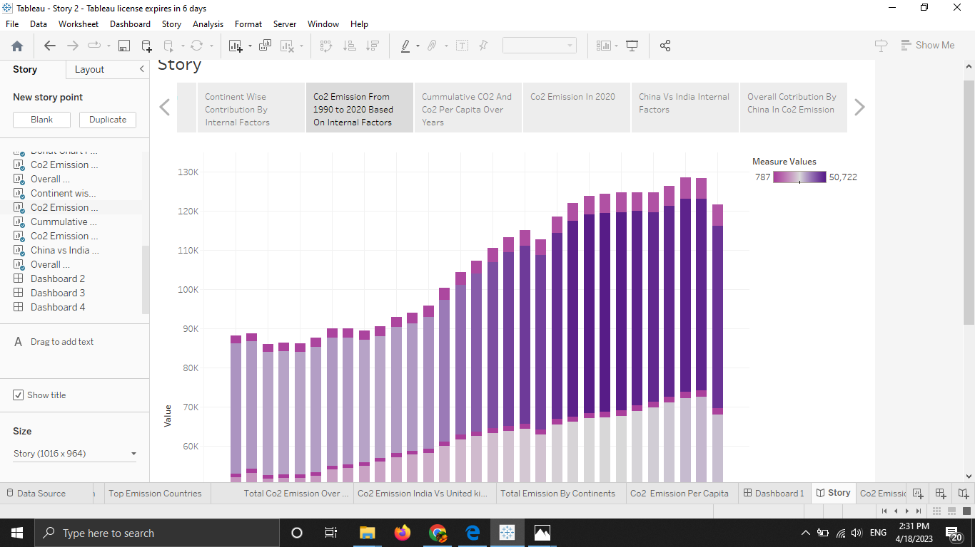

Fig 6: Story

# ADVANTAGES OF CO2 EMISSION ANALYSIS IN TABLEAU

**1. Data visualization** - Tableau provides powerful tools for creating visualizations that can effectively communicate complex data to a variety of audiences. CO2 emissions analysis can be presented in a variety of charts, graphs, maps, and dashboards, which enable analysts to identify trends and patterns more easily than in traditional spreadsheets or tables.

**2. Interactive dashboards** - Tableau allows users to build interactive dashboards that enable users to explore and interpret data in real-time. This means that analysts can quickly dig deeper into CO2 emissions data to identify patterns, outliers or relationships for further analysis.

**3. Centralized data** - CO2 emissions data can be imported from multiple sources and consolidated into a central location on Tableau. This allows for more efficient analysis and reduces the need for multiple data sources.

**4. Data collaboration** - Tableau enables users to collaborate and share their findings with other teams or stakeholders with ease. By providing an interactive platform that allows users to explore and interpret data, Tableau encourages collaboration and a sharing of ideas and knowledge to help overcome business challenges.

**5. Actionable insights** - The insights gleaned from CO2 emissions data analyzed on Tableau can translate into actionable measures that can reduce carbon footprint, identify sustainability initiatives, and promote environmental stewardship in organizations.

# DISADVANTAGES OF CO2 EMISSION ANALYSIS IN TABLEAU

**1. Data Availability** - Obtaining reliable data on CO2 emissions can be challenging, as it may not always be readily available or accurate. This can lead to incomplete or inaccurate analysis, which may lead to misguided or ineffective responses to sustainability.

**2. Complexity** - CO2 emissions analysis can be complex, especially if there are a large number of data points to analyze or if the dataset is very large. Dealing with complex data can be time-consuming and require advanced analytical skills.

**3. Software Constraints** - Tableau software can be expensive, and requires a certain level of expertise to use successfully. This can be discouraging for organizations that may not have the resources or expertise required to use these tools effectively.

**4. Lack of Standardization** - There is a lack of standardization in how organizations report CO2 emissions data, which can make it difficult to obtain a consistent set of data for analysis. This can make it challenging to compare CO2 emissions across industries, regions and countries.

**5. Limited scope** - CO2 emissions analysis in Tableau may be limited to a specific organization or organization's scope, and may not incorporate emissions from its full supply chain or other indirect emissions sources, which could lead to an incomplete analysis.

# APPLICATIONS

CO2 emissions analysis in Tableau is an advanced application that leverages the powerful data visualization and analytical tools of the Tableau software to create interactive dashboards, reports and visualizations of CO2 emissions data. The application of CO2 emission analysis in Tableau includes:

**1. Analysis of different time scales data**: Tableau software is capable of analyzing and visualizing large volumes of CO2 emissions data spanning multiple years or decades. This allows organizations to identify trends and patterns, monitor progress, and make informed decisions about strategies and policies for reducing greenhouse gas emissions.

**2. Interactive dashboards**: Tableau software enables the creation of dynamic dashboards, which provide a customizable, simple visualization of CO2 emissions data. Dashboards can be shared with stakeholders to plan and track the effectiveness of emissions reduction strategies.

**3. Spatial analysis**: Tableau can be used to analyze CO2 emissions data spatially, providing insights into emissions from specific regions, industries, and activities. This allows organizations to develop targeted, location-specific strategies to reduce emissions.

**4. Cross-functional analysis**: Analyzing CO2 emissions data within Tableau can provide insights into the inter-relationship between various factors and the impact of CO2 emissions on the environment, human health and the economy. This type of cross-functional analysis helps to identify the most significant contributors to CO2 emissions, and develop and prioritize effective emissions reduction strategies.

# CONCLUSION

CO2 emissions analysis in Tableau offers a powerful tool to obtain insights into greenhouse gas emissions and identify opportunities for reducing carbon footprint in organizations or mitigating climate change impacts. Tableau is a practical tool for the analysis, visualization and management of CO2 emissions data. Its interactive capabilities help identify trends and inter-relationships in emissions data, leading to targeted mitigation strategies that promote sustainable business and policy practices.

# FUTURE SCOPE

**1. Real-time data visualization**: The ability to visualize real-time emissions data as it is being collected would allow for more accurate and timely analysis. This would require the development of data sources that can stream data in real-time and the ability to create real-time dashboards.

**2. Integration with climate models**: Tableau can be used to create visualizations that show the impact of climate change and the effectiveness of different mitigation strategies. Integration with climate models would allow for more accurate projections of emissions trends and the effectiveness of different policy interventions.

**3. Improved geospatial analysis**: Tableau can be used to create maps and spatial visualizations of emissions data. Improvements in geospatial analysis could include the development of more accurate emissions datasets and the ability to conduct more complex spatial analysis.